Ow! How to add an opportunity?

1. Go to the devex website and login

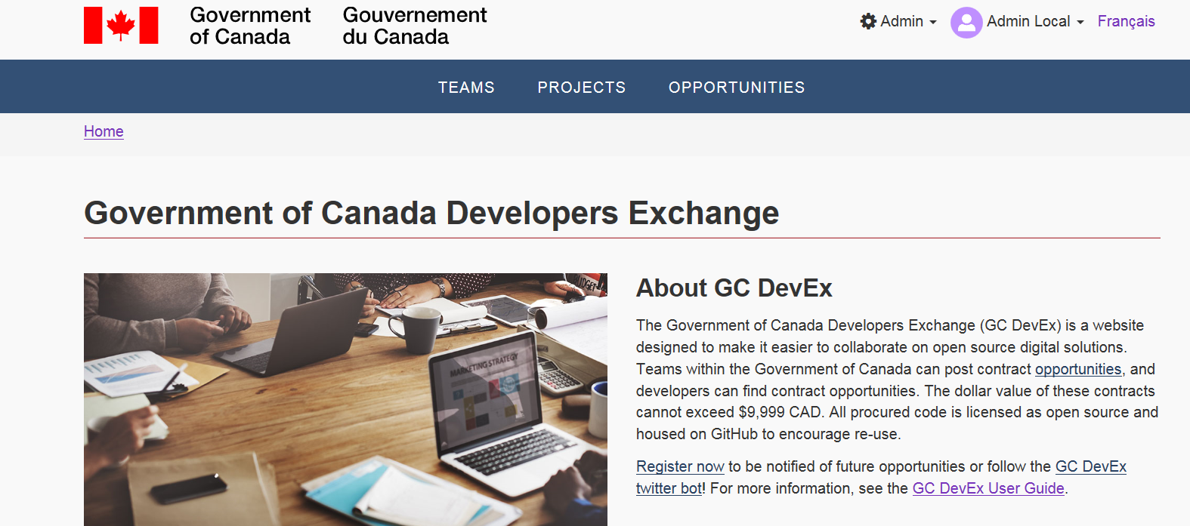

2. Click on the opportunity tab